// Time and Space Complexity –
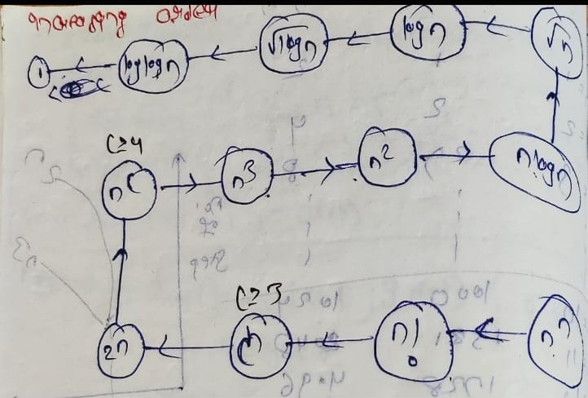
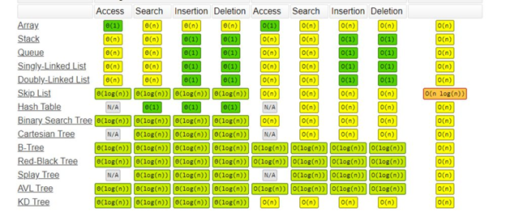

// int n;
// cin >> n;
// // 1 -
// for (int i = 1; i <= n; i++)
// {
// cout << i << endl;
// }
// // O(n)

// // 2 -
// for (int i = 1; i <= 2 * n; i++)
// {
// cout << i << endl;
// }
// // O(2n) = O(n)

// // 3 -
// for (int i = 1; i <= n; i++)
// {
// cout << i << endl;
// }
// for (int j = 1; j <= n; j++)
// {
// cout << j << endl;
// }
// // O(n+n) = O(2n)

// // 4 -
// for (int i = 1; i <= n; i++)
// {
// for (int j = 1; j <= 5; j++)
// {
// }
// }
// // O(n*5) = O(n)

// // 5 -
// for (int i = 1; i <= n; i++)
// {
// for (int j = 1; j <= n; j++)
// {
// cout << j << endl;
// }
// }
// // O(n*n) = O(n^2)

// // 6 -
// for (int i = 1; i <= n; i += 2)
// {
// for (int j = 1; j <= n; j++)
// {
// cout << j << endl;
// }
// }
// // O((n/2)*n = O(n^2))

// // 7 -
// for (int i = 1; i <= n; i *= 2)
// {
// cout << i << endl;
// }
// // O(log2n)

// // 8 -
// for (int i = 1; i <= n; i *= 2)
// {
// for (int j = 1; j <= n; j++)
// {
// }
// }
// // O(n*log2n)

// // 9 -
// for (int i = 1; i <= n; i *= 2)
// {
// }
// for (int j = 1; j <= n; j++)
// {
// }
// // O(log2n + n) = O(n) dominates as bigger than logn
What can be implemented –
Here's a quick guide based on the value of (n):
- If n <= 12 Time complexity can be O(n!).
- If n <= 25 Time complexity can be O(2^n).
- If n <= 100 Time complexity can be O(n^4).
- If n <= 500 Time complexity can be O(n^3).
- If n <= 10 ^ 4 Time complexity can be O(n^2).
- If n <= 10 ^ 6 Time complexity can be O(n log n).
- If n <= 10 ^ 8 Time complexity can be O(n).
- If n > 10 ^ 8 Time complexity can be O(log n) or 0(1).
- If n <= 10 ^ 9 Time complexity can be O(sqrt{n}).
- If n > 10 ^ 9 Time complexity can be O(log n) or 0(1).


Details for solving qun –
n ≤ 10 → O(n!), O(2^n)
n ≤ 20–25 → O(2^n)
n ≤ 100 → O(n^3), O(n^4)
n ≤ 500 → O(n^3)
n ≤ 10^4 → O(n^2)
n ≤ 10^5–10^6 → O(n log n)
n ≤ 10^7–10^8 → O(n)
n ≤ 10^9 → O(√n), O(log n)
n > 10^9 → O(log n), O(1)
TIME COMPLEXITY VS INPUT SIZE (CHEAT SHEET)
n ≤ 10
→ O(n!), O(2^n)
→ Permutations, backtracking, brute force

n ≤ 20–25
→ O(2^n)
→ Subsets, bitmasking, recursion

n ≤ 100
→ O(n^3), O(n^4)
→ DP, matrix DP, Floyd–Warshall

n ≤ 500
→ O(n^3)
→ DP, graph all-pairs

n ≤ 10^4
→ O(n^2)
→ Nested loops, brute force with pruning

n ≤ 10^5 – 10^6
→ O(n log n)
→ Sorting, binary search, heap, divide & conquer

n ≤ 10^7 – 10^8
→ O(n)
→ Prefix sum, sliding window, hashing

n ≤ 10^9
→ O(√n), O(log n)
→ Math, binary search, prime checks

n > 10^9
→ O(log n), O(1)
→ Math formulas, bit tricks
🧠 WHAT ALGORITHMS FIT EACH RANGE
✅ O(n!) / O(2^n)
- Permutations
- Subsets
- Backtracking
- Bitmask DP

✅ O(n^3)
- Floyd–Warshall
- Matrix DP
- 3D DP
- Some graph problems

✅ O(n^2)
- Brute force with pruning
- Prefix comparisons
- 2D array traversal

✅ O(n log n)
- Sorting
- Merge Sort / Heap Sort
- Binary Search
- Maps & Sets
- Divide & Conquer

✅ O(n)
- Two pointers
- Sliding window
- Prefix sum
- Hashing
- Linear scan

✅ O(log n) / O(1)
- Binary search
- Bit manipulation
- Math formulas
//_________________________________________

// Space Complexiotyu -
// int n;
// cin>>n;

// // 1 -
// int arr[n];
// // O(n)

// // 2 -
// int matrix[n][n];
// // O(n^2)+O(n) = O(n^2)

// // 3 -
// int rev = 0;
// while (n!=0)
// {
// rev = rev+10+n%10;
// n/=10;
// }
// cout<<rev;
// // S.C - O(2) - for 2 var n&rev, both are constant = O(1)
// // T.C - Jitne digits utne complexity. 2 times step - 1) for modular & 2 for division - so O(2*no. of digits in no.) = O(No. of digits)

// ____________ ____________ ____________ ____________ ____________

